Sop
for FRS Device Configuration and Installation

 | Created By | Reviewed By | Approved By
Name
Designation
Organization
Signature
Date

SOP: Setting of FRS Device configuration and Installation
Document Purpose
This document outlines the detailed procedure for FRS device configuration, its installation and integration with Turnstile/Barrier system.
Installation Diagram:
The mounting of FRS device will happen on a mounting plate which attached to a mounting pole, as shown in the adjacent figure.
The mounting pole is mounted on top of the Tripod Turnstile to get suitable height.
The height of mounting pole can be adjusted from 1155mm to 1300mm from top of the turnstile.
Also, there is an arrangement in the mounting pole to rotate the angle of the FRS reader from -45° to +45° from the central axis.
Once all the above mounting arrangements are done, then FRS reader is fixed to the mounting plate and the cables are left inside the mounting pole, for making connection with the Tripod Turnstile.
The following diagram shows most suitable mounting arrangements for the FRS reader so that it is fit for maximum height variation of people.
Connections:
Pre-requisites:
Kindly make the jumper settings as shown in the following figure, i.e., SW1700 in Power On position.
Connect the 7-pin connector and 5-pin connector to J1901 and J1902 respectively on the mainboard.
Once above jumper settings and connector connections are proper, then we proceed to the actual wiring connections.
Turnstile Actuation:
Connect NO and COM of Lock1 from the 7-pin connector to the Turnstile Entry Actuation Circuit. This connection will operate the turnstile on successful authentication of an associate.
Feedback of Turnstile Rotation:
Similarly, for monitoring the feedback from turnstile on successful authentication, kindly connect the two wires from turnstile relay output to DM0 and GND of the 5-pin connector.
Exit/Emergency Switch (Optional):
Kindly connect exit/Emergency switch to Turnstile Exit Actuation circuit, to allow free exit for the associate in emergency conditions.
Configuration:


- On receiving new device, Godrej Service Engineer will power on the device and configure the new device with assigned Terminal ID by Godrej HO for that location without putting it on the network. For this go to menu and then tap network.
- Godrej Service Engineer will connect the device with Mobile Hotspot before installing it on Turnstile and ensure that device is handshaking with ALPETA Server.
- Godrej HO team will assign the same Access Group for the Same terminal ID, so that all the respective templates are ensured to be transferred for that particular device with the respective Terminal ID to the new device from backend.

- MAC ID Binding:
- For binding the MAC ID of the newly installed device in L2 switches, kindly enter into device Settings using admin ID and password.
- Once correct credentials are provided, Settings page will open.
- In Settings, kindly go to Info.
- In Terminal Info, kindly go to Network Settings.
- Here you will find the Device MAC ID which needs to be entered in the L2 Switch settings, for binding the device with a particular port in the switch, for network security.

System Settings:
Settings | Screen
- System
  - User ID Length: 8
  - Authentication: Terminal only
  - Mandatory Registration: To be left unchecked
- Finger
Sensitivity Levels
  - 1:N Level - 5
  - 1:1 Level – 4
Other Finger Settings
  - Fake Finger Detection: None
  - FP Template Format: Union
  - Check Similar FP: Checked
  - Multi FP: Unchecked
  - Enable 1:N: Checked
- Face  - Verified Distance: ~0.9meter  - Mask Detection: None  - AE Flicker Frequency: 60  - AE Mode: Full  - Anti Spoofing: Checked  - Enable LED Lighting: Checked  - Multi Face Detection: Unchecked | 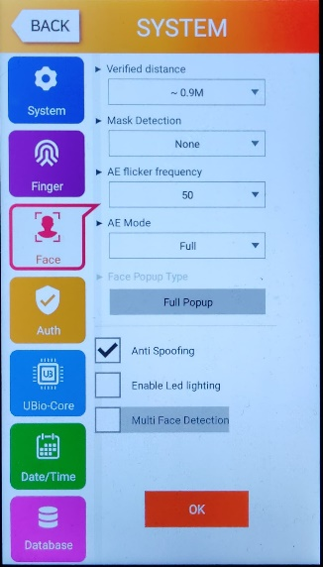
- Auth:  - Auth Type: None  - Forced Function Key: Unchecked | 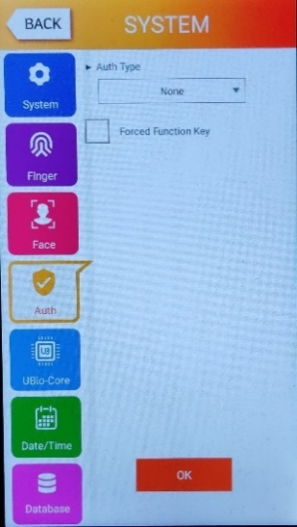
- UBio Core: Not to be touched | 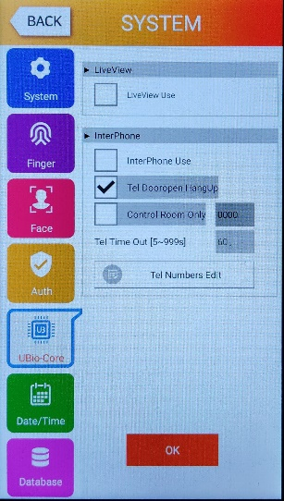
- Date Time:  - Time Synchronization: Auto  - Nothing else to be changed. | 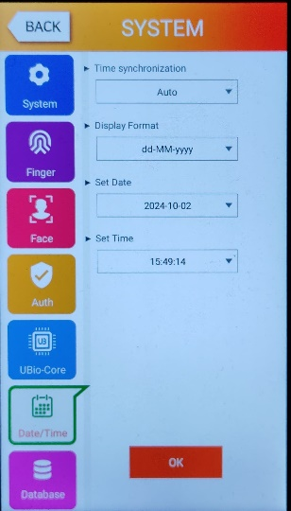
- Database (None of the following setting is to be touched unless required)
- Delete All Users
- Delete Setting
- Delete Log
- Delete Image Log
- Factory Init
- Reboot
- Restart App

Display Settings:
- Camera  - Save Success Log: Checked  - Save Failed Log: Checked  - Save Failed Face: 3 | 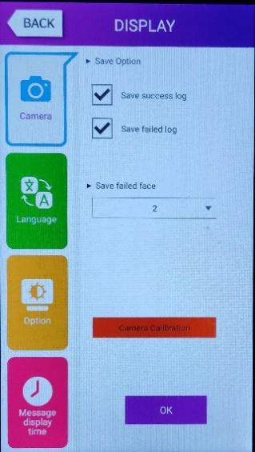
- Language: English

- Option
  - Power Saving Mode: 5min
  - Display Option: Username

- Message Display Time: 3000ms

Terminal Settings:
- Sound
  - Sound Volume: Maximum
  - Beep Volume: Maximum
  - Sound Option: User Voice
- Option
  - Read Card Number: To be kept Blank
  - Card Format: Standard
  - Ble Rssi: 3
  - Ble TxPower: 2
  - Lock Terminal: Checked
- Input
Since only one input is used to get the feedback from the turnstile, it needs to be configured, once the connection with turnstile relay output.
  - M0: Turnstile Monitor NO
  - M1: None
  - M2: None
  - IO: Inside Open NO
  - Tamper alarm: Unchecked
- Lock:
  - Lock 1 Option: Strike/Auto/OK
  - Lock 2 Option: Fail
  - Lock 1 Duration(ms): 300
  - Lock 2 Duration(ms): 300
- External Device:
RS232: None
RS485: None
Wiegand:
Site Code: 0
Wiegand Output: None
Wiegand Input: None

None of the options in this device are to be changed.
- ETC(Thermal)
This setting is used if a Thermal Camera is attached to the device.
Currently any of the configuration in this setting is not to be touched since Thermal Camera is not being used.
Network Settings:
Parameters | Screenshot
- Kindly select the DHCP setting, presuming device is connected to internet BPCL SD-WAN network. The IP address will be automatically assigned to the device.  - Set the Server IP address to 65.2.49.63  - Port No. 9003  - Terminal ID: As per the allocation of ID based on Locations | 